**Exercise 1: Inventory Management System**

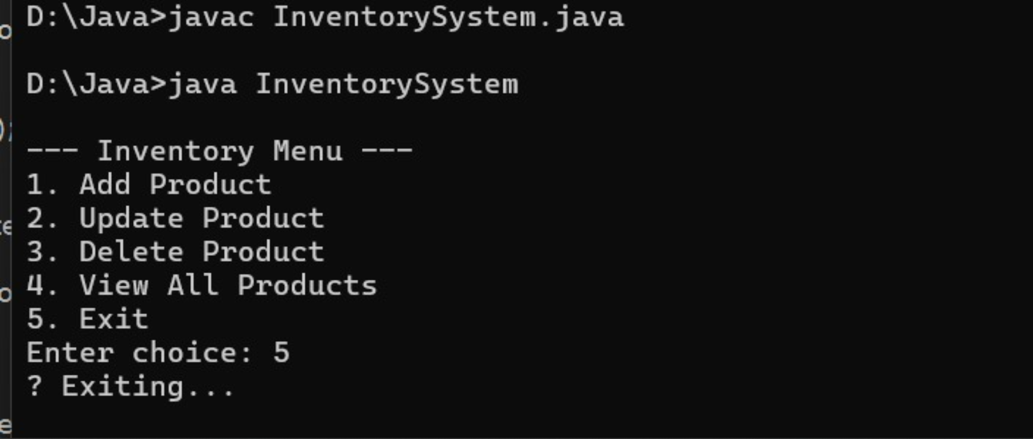

**Exercise 2: E-commerce Platform Search Function**

